



UK

**UTC Chubb Process Summary**

May 24, 2018

**Title of Document**

Title of Document

1. Table of Contents 2

2. Introduction 3

3. As-Is Business Process Flow Chart 4

4. As -Is Business Process Overview 5

*Step 1.* Template Opportunity Creation 5

*Step 2.* Contract template selection 5

*Step 3.* Site Information 6

*Step 4.* System Information 7

*Step 5.* Monitoring & Maintenance 8

*Step 6.* Risk 9

*Step 7.* Item Selection 10

*Step 8.* Pricing 13

*Step 9.* Annual Charges 14

*Step 10.* Commission Report 15

*Step 11.* Output Forms 16

*Step 12.* Approvals Flow 19

*Step 13.* Customer accepts quote 21

*Step 14.* Scan & Upload (Paper Clip) 21

5. Current Pain Points in existing Tool 23

➢ Current Pain Points 23

➢ Aspirations from new CPQ Tool 23

6. Appendix 24

# Introduction

UTC Chubb has engaged L&T Infotech (LTI) to provide consulting services and help select CPQ platform as to be solution across all Chubb business units. In the future state, the business units will use Microsoft CRM for sales force management and JDE for ERP. The target CPQ solution will address the needs of the business units around deal configuration, pricing and quoting, as well as integration with the respective back office systems.

There are 3 stages in the study,

*Phase 1 - Pre-workshop*

*Phase 2 – Workshop*

*Phase 3 - Post-Workshop follow-up*.

We are currently in the Phase 1 and need to understand the current Quotation process, business pain points and needs. The session we are describing below is for Security Systems using i-Sales Tool. We understand that similar tool is used for Fire systems.

Based on the initial questionnaire and subsequent discussion the document has been created. As Chubb SME, please confirm the understanding and highlight if anything has not been captured which can affect the outcome of the study, especially around:

* Current state and processes followed
* Product Structure and pricing
* Business rules and workflows
* Challenges and pain-points

# As-Is Business Process Flow Chart

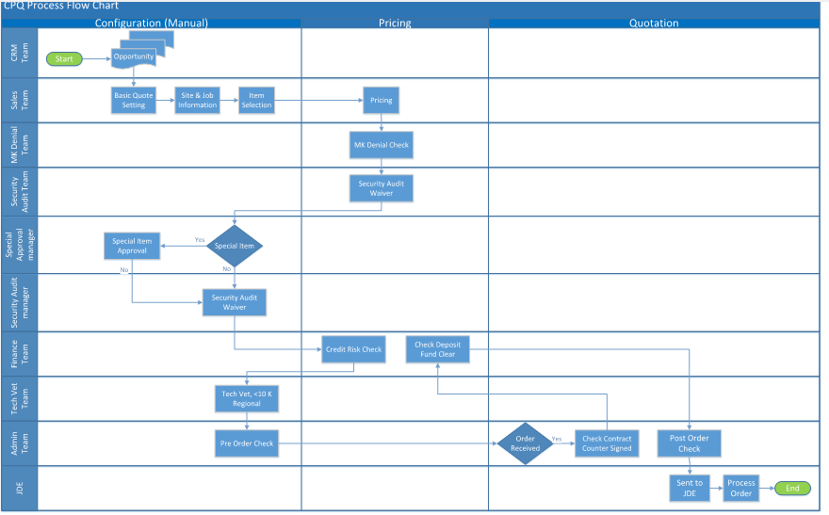

Figure 1: Chubb UK as-is process

# As - Is Business Process Overview

## Template Opportunity Creation

Opportunities/Leads are created in MS Dynamic CRM, which triggers creation of a corresponding template for opportunity/lead in iSales. Typically, the iSales templates have a few fields pre-populated and others can then be edited/updated.

## Contract template selection

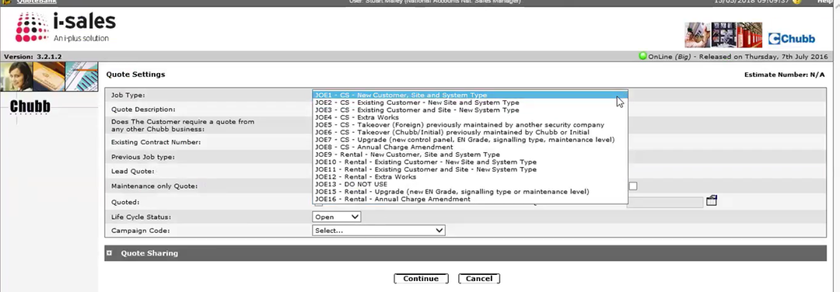

Figure 2: iSales quote template selection

#### Types of contract templates –

Depending the payment mode selected/proposed to the customer, there are two types of contracts -

##### Outright contacts & Rental contracts

These contract types are based on how the contract payments are done – whether upfront or in instalments -

Each of these contract types are further divided based on the kind of customer/ site and system.

* New Customer

Template for new customers is an exhaustive template, as no customer data is stored in JDE. Sales representative must populate all details related to customer while preparing a quote.

* Existing Customer

Templates related to existing customer will have details of customer fetched from JDE database

* New Site
* Existing site
* Takeover from competitor
* Takeover of a site which was earlier manager by Chubb
* Upgrade
* Annual change amendment

## Site Information

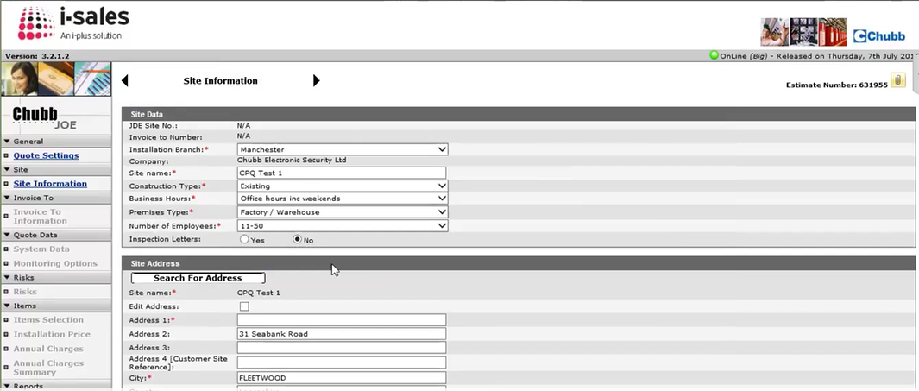

Figure 3: Site information dialog

There are two kinds of site information that are required while preparing a quote in iSales -

* Job site
* Invoicing site

Upon contract approval, this site information is pushed into JDE along with customer information for further processing.

Note: External source viz. “Experion” (a web services which verifies information of UK business & addresses) is used to verify the customer information.

## System Information

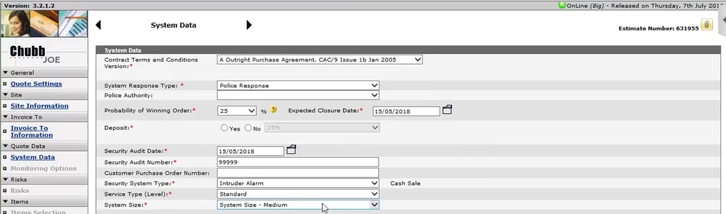

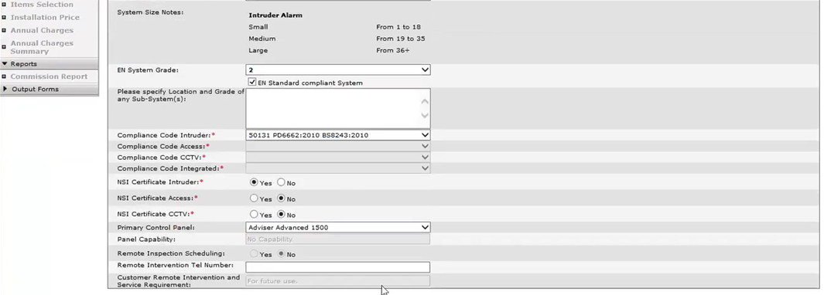

Figure 4: System information dialog

User is asked about various system parameters which will help in sizing of the contract such as -

* System response type
* System Size
  + Small (1 to 18 Components)
  + Medium (19 to 35 Components)
  + Large (36 + Components)
* System grade & location
* Compliance codes, certification and other details

## Monitoring & Maintenance

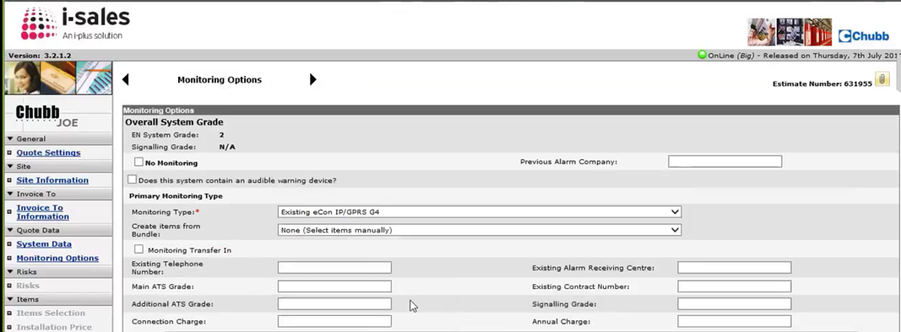

Figure 5: Monitoring & Maintenance dialog

Depending on the system grade entered earlier, user is asked to provide information for various monitoring parameters such as fire, personal attack, intruder confirmed\unconfirmed, AC main Fail, Tamper, General Fault

## Risk

Risks associated with the quote has to be selected for legal requirements (default selection is no).

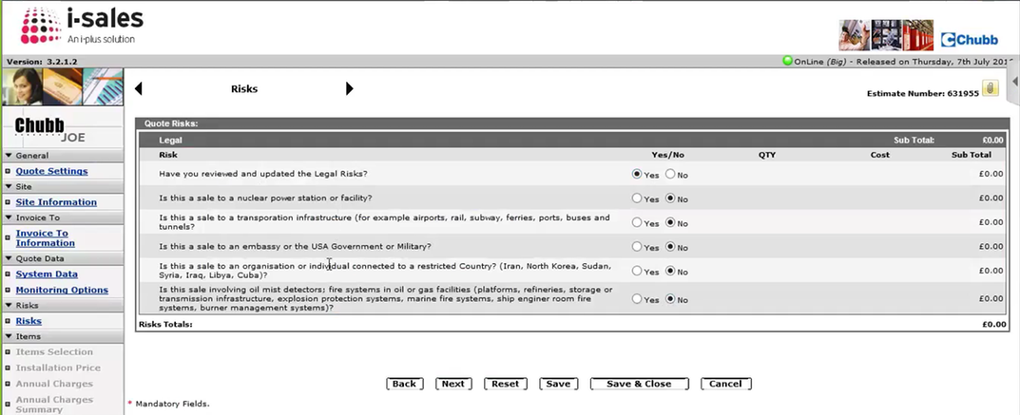

Figure 6: Risks

## Item Selection

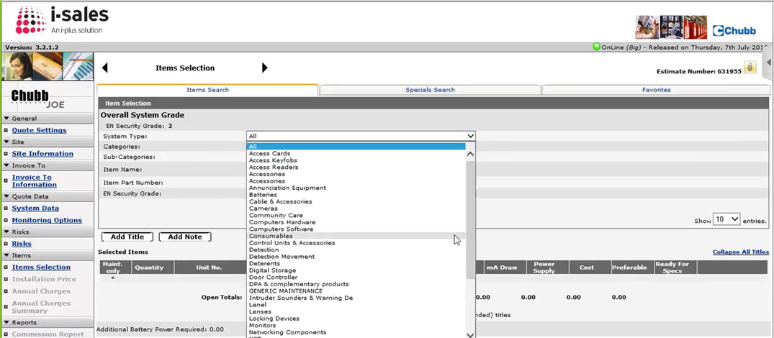

Figure 7: Item Selection

Item selection is where the salesperson will be able to build the configuration for this particular system. Salesperson will be able to select products at this stage by searching through the product catalog. Search through the catalog can be conducted either through the cascading drop downs or by looking-up the product through the part id.

It is important to note here that all the items are selected by Salesperson based on his own expertise and understanding of user requirements. These are not validated by the system. In the approval chain there is an required approval by Tech Vets, which validates this design. This approval will happen either before or after quote submission, based on the quote value (above and below 10k GBP).

Salesperson also can select preconfigured packages at this stage from the available option. These packages contain an assembly of multiple items within a single line item.

There are two categories of items available for selection –

* Standard items which are generally available from UTC
* Special items –

Specific type of equipment’s the customer requires especially for this order. These special items are available only for the person who has created them i.e. these will not be available for any other quote in iSales by any other user. Further, full item information will have to be entered while adding the special product. It also triggers a special approval in the approval stage if a special item is present in the quote.

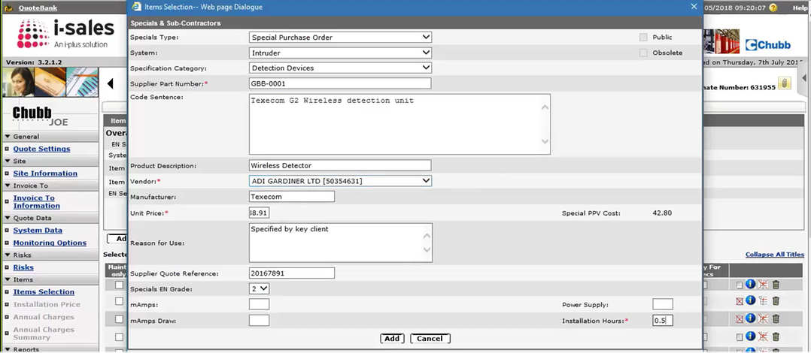

Figure 8: Special product creation dialog

Once the items which are needed in the system design are identified, the salesperson will now be able to provide details at item level by selecting “Add to title” from the item selection screen. Salesperson will also be able to provide quantity of each item at this stage.

Each line item with quantity greater than 1 can be decoupled to create individual line records where boilerplate text can then be added at item level.

The typical information which is added here is area & location where the item will be installed.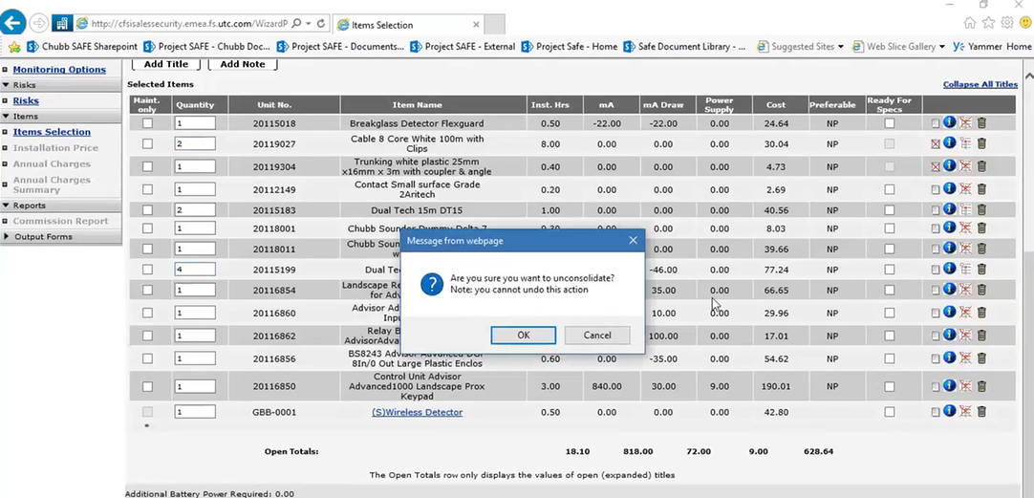

Figure 9: Before decoupling

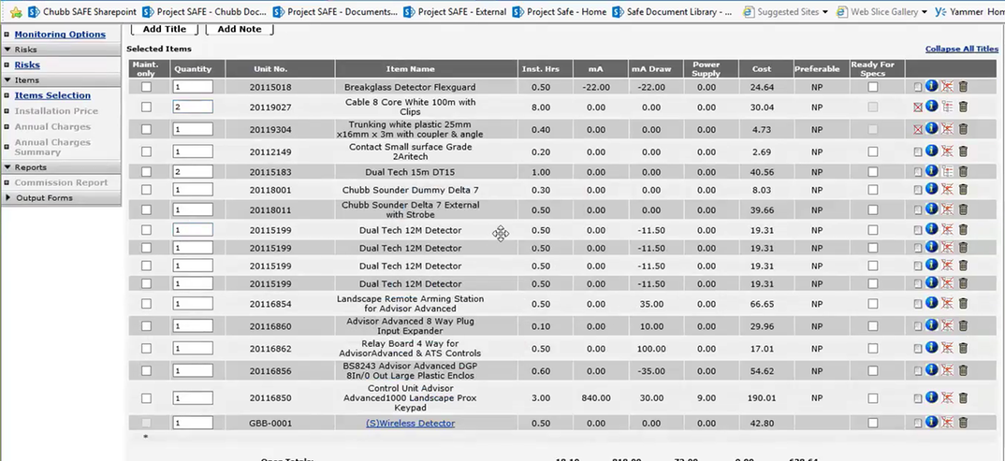

Figure 10: After decoupling

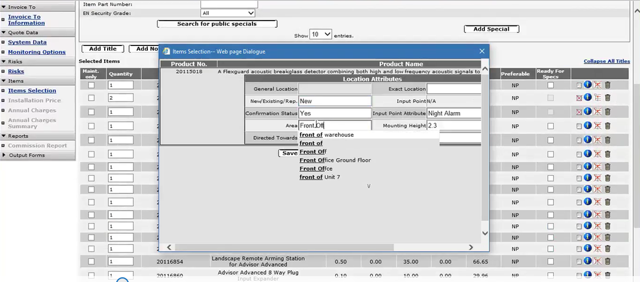

Figure 11: Information provided for each item

## Pricing

iSales pre-calculates the hour it takes for installation job for the job and gives the consolidated price for installation of items selected.

The hours are rounded off in step of 4 or 8 hours; also, adjustments can be made for the addition and reduction of hour if required to accommodate the complexity or ease of installation

Example: Addition of hours required if the access to locations in buildings or facilities is restricted.

It also calculates the materials, or any special items required for Installation and provides total Installation cost.

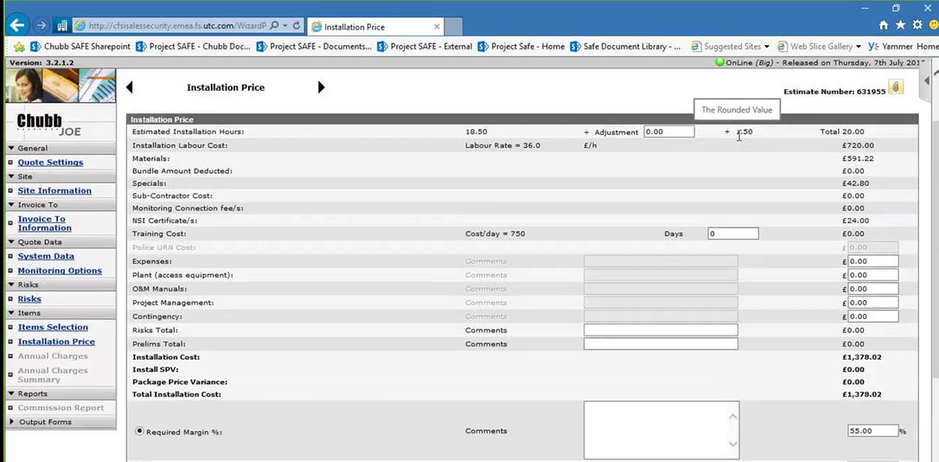

Figure 12: Pricing screen

The Cost calculated here is **Cost plus margin,** to determine the selling price. The default Margin is 55%

Lowering of default margin is part of competitive strategy for business, however lowering the margin below the default iSales suggested one, will require approval.

## Annual Charges

Salesperson has the option of adding an annual service contract at this stage. Annual charges or the recurring revenue\portfolio charges are divided further into Monitoring and Maintenance;

* The Monitoring charges are auto populated based on the parts selected in the list

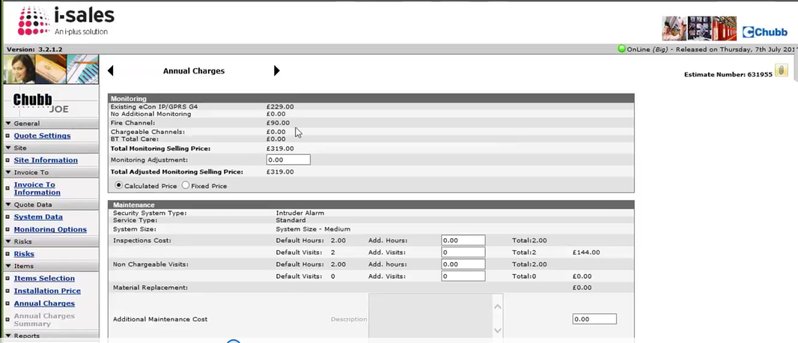

Figure 13: Monitoring charges

* Maintenance charges which provides a default effort of 2 hours for inspection & visit each and can be modified, if required. The maintenance price is total price plus the Margin.

Note: There is a default margin of 70% for the maintenance cost & lowering the margin requires approval.

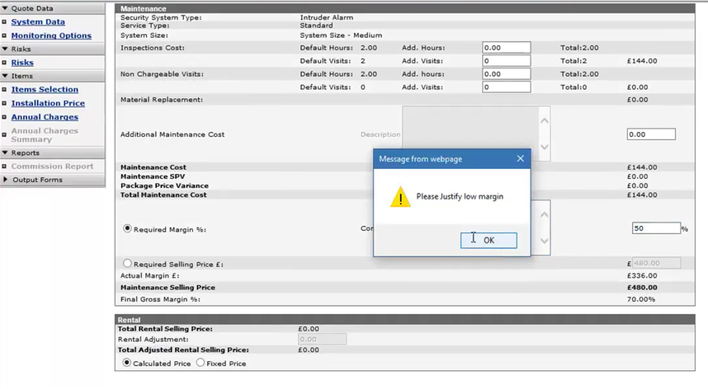

Figure 14: Maintenance charges

## Commission Report

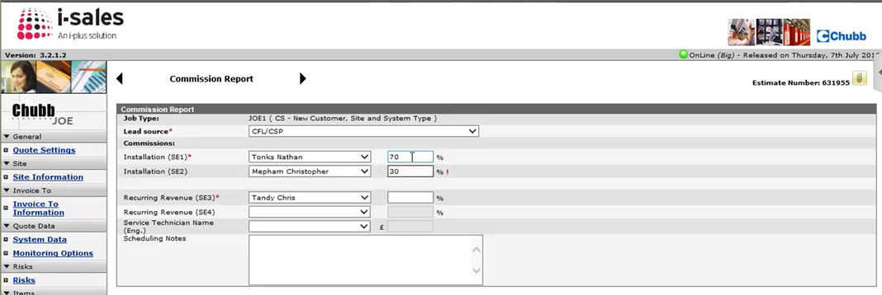

Figure 15: Commission report

Salesperson can enter commission incentive information for installation & recurring revenue in this screen. There is also an option of claiming 100% commission to individual sales personnel or it can be split into proportions.

## Output Forms

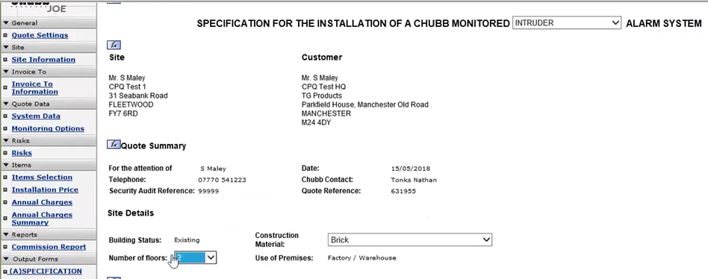

Figure 16: Output specification form

Once all the information is entered into the system, the salesperson will need to provide specification for Chubb monitored alarm system.

At this stage the user also gets the ability to select output forms which will be part of the final quote to be submitted to the customer. As per ISO requirement, there are number of standard texts that are required to be included here and forms which are appropriate with the order needs to be manually selected.

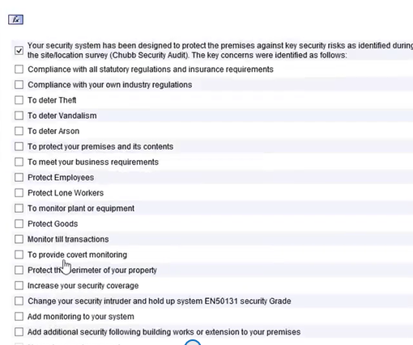 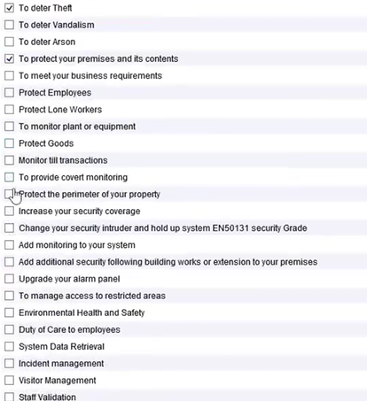

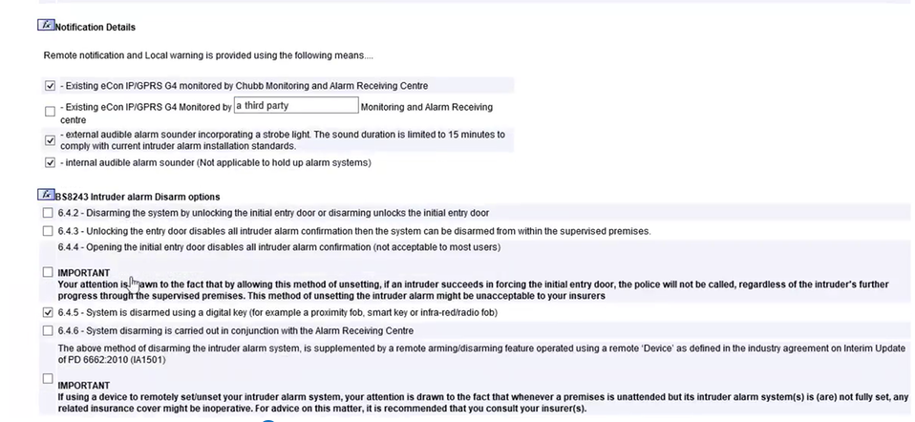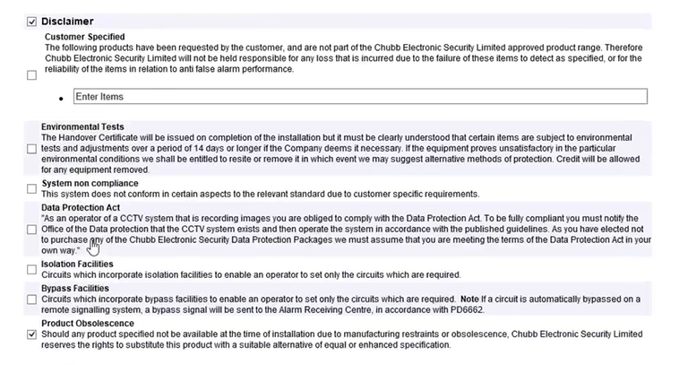

Figure 17: Output form selection

Other screens in this section are summarized in the table below –

|  |  |
| --- | --- |
| Billing Data change form |  |
| Critical data change form |  |
| Costing Sheet (Goes to local branch and engineer) |  |
| Data Entry Sheet |  |
| Quotation Part of the Proposal |  |
| Cover letter |  |
| Monitor & keyholders form |  |
| Non-Critical Data change form |  |
| Price summary form |  |
| Proforma Invoice (Information on 25% deposit) |  |
| Quick Quote form |  |
| Green ticks in front of all the filled forms |  |

All the forms selected/ filled till now, can be merged to create a quote/proposal, which will be in draft stage as the approvals needed for the quote are not yet gone through. Once the quote is approved, the document will no longer be in draft stage.

## Approvals Flow

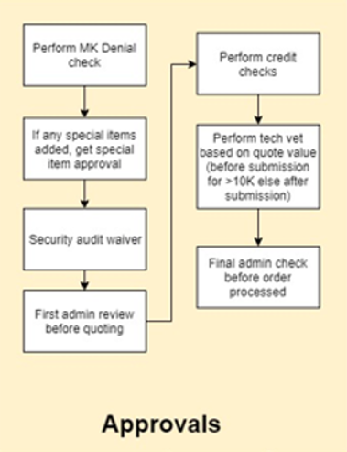

Figure 18: Approval flow

The quotation created can be sent for approval in the system by selecting “Send for approval” from the iSales home screen;

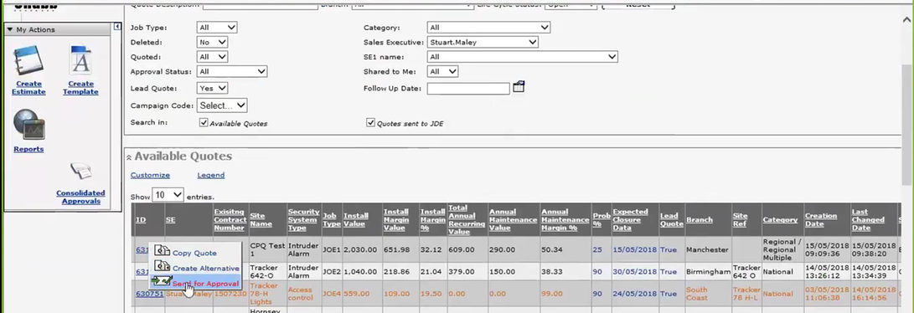

Figure 19: Send for approval kick-off

There are different types of approval required with seven different approvers to enable to complete the jobs above 20K Pounds

1. **MK Denial Check**

This approval is required to make sure that the UTC can do business with customer-

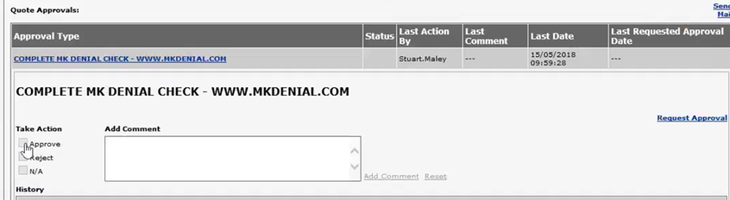

Figure 20: MK Denial check

1. **Special Approval**

It is only required in case a special item is added in the quote in item selection screen.

1. **Security audit waiver**

Approval required from General manager in each branch to proceed with quotation

1. **Admin review (Before)**

Once the isales proposal documents is uploaded to Paper clip option in Quotes setting then it is made available for Admin team to review

1. **Customer Order receipt\ Contract counter signed**

The Customer order receipt is reviewed after it is signed by the customer

1. **Credit risk check < 2.5 K pound Regional (BA, AS)**

Credit check is done by the finance

1. **Pre order Tech Vet, < 10K Pound Regional (BA, AS)**

Tech vet is the process wherein the quote’s configuration is reviewed and approved by technical experts. This is to make sure the correct instillation quote is provided to correct quote to customer.

Tech vet is performed before submission to customers if the order value is greater than 10k.

1. **Deposit paid / Fund cleared <10K Regional**
2. **Admin review (Before sending to JDE for order processing) -** Once all the approvals are completed, admin team sends the quotes to JDE to complete the order after reviewing it one last time.

## Customer accepts quote

## Scan & Upload (Paper Clip)

The Customer accepted signed copy of proposal is uploaded to iSales with paper clip option in Quotes setting

|  |  |
| --- | --- |
| Select paper clip |  |
| Upload document |  |
| Paper clip step done |  |

# Current Pain Points in existing Tool

## Current Pain Points

* Different Tools for different Product Lines within Countries
* Current Tools are not User friendly and has steep learning curve for New Sales Rep.
* Requires significant knowledge to use the tool.
* No Configuration Component in any of the current tools
* Some tools have no built-in approval workflow, happens outside of the system
* Most of the cases there is no CRM – JDE integration. CRM Data / Product Master / Pricing information etc., all build in tool
* Tools are Desktop based and hence unable to promptly give quotes at customer site
* Many cases the tool is excel based and hence requires data re-entry in other systems
* No Dashboard to look at what stage of lifecycle is the proposal
* In some cases the cost from ERP is an average cost, and not a real cost in order to make informed decisions

## Aspirations from new CPQ Tool

* Solution based guided selling that drives incremental revenue
* Full visibility into quoting lifecycle across all channels
* Integration with Pricing Analytics for optimized pricing and Sales Compensation that drives higher revenue and margins
* Automated approval workflows for pricing, contract terms or offerings exception as part of deal management process
* Quote details that drive supply chain planning, revenue and margin projection
* Business managed CPQ rules
* On demand analytics available across functions
* Offering and Pricing rules are imbedded in CPQ & integrated with cost, customer, contract and entitlements master data
* Granular pricing margins & discounting visibility for all pricing models
* CPQ integrated with ERP with Order conversions and Order status write back to Sales/Opportunities
* Renewals are enabled by CPQ engine for all routes to Market
* Defined set of analytics captured and reported on standard cadence

# Appendix

|  |  |
| --- | --- |
| **Document** | **Sample** |
| Sample Contract |  |
| Security Quotation Sample |  |
| Fire Quotation Sample |  |
| Security Specification Sample |  |
| Fire Specification Sample |  |
| Security Authority Matrix |  |
| Fire Authority Matrix |  |
| Order Acceptance Criteria |  |
| Security Package Calculator |  |
| Product Assembly Sample |  |
| Design |  |